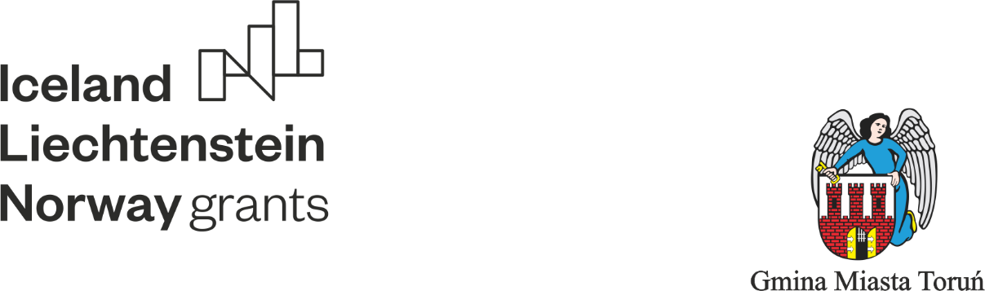

**PROGRAMME OF STUDY VISIT TO VOCATIONAL SCHOOLS IN TORUN**

**MONDAY, 30.05.2022.**

Arrival of the group from Iceland and Norway at Gdańsk airport

Transfer of the project participants to Toruń, to Nicolaus Hotel, and to Bulwar Hotel and accommodation.

**TUESDAY, 31.05.2022**

8.00 Transfer of the project participants from Iceland and Norway to the Complex of Technical Schools in Toruń

8.30 - 9.15 Polish vocational education system (curricula, management system, exams confirming professional qualifications).

9.15 - 9.30 Coffee/tea break

9.30 – 10.00 Technical visit to the Complex of Technical Schools in Toruń (information about the school, educational offer, curricula, exams confirming vocational qualifications, cooperation with employers, inclusive education/integrative teaching, ICT usage, didactic base).

10.00 - 10.30 Transfer of project participants to the Gastronomic and Hospitality School Complex in Toruń

10.30 Technical visit to the Gastronomic and Hospitality School Complex in Toruń (information about the school, educational offer, curricula, exams confirming vocational qualifications, cooperation with employers, inclusive education/integrative teaching, use of ICT, teaching facilities)

11.00 Demonstration lesson of practical training for students with special needs.

11.30 - 12.15 Lunch at the Gastronomic and Hospitality School Complex in Toruń

12.15 Transfer of the project participants to the Complex of General and Technical Secondary Schools No. 13 in Toruń

12.45 – 13.45 Technical visit to the Complex of General and Technical Secondary Schools No. 13 in Toruń (information about school, educational offer, curricula, exams confirming vocational qualifications, cooperation with employers, inclusive education/teaching, use of ICT, teaching facilities)

13.45 Transfer of project participants to the School Complex No. 26 in Toruń

14.15 -15.30 Technical visit to the School Complex No. 26 / School Assimilating to Work in Toruń ( information about school, educational offer, curricula, cooperation with employers, teaching facilities, practical job preparation classes).

15.30 – 17.00 Tour of the Astronomical Observatory in Piwnice.

**WEDNESDAY, 01.06.2022**

9.00 – 9.30 Adult education in Poland / Lifelong Learning Centre in Toruń.

9.30 – 10.30 Technical visit to the Lifelong Learning Centre in Toruń (adult vocational education in Poland, information about the school, educational offer, curricula, exams confirming vocational qualifications, cooperation with employers, inclusive education/teaching, use of ICT, didactic base).

10.30 – 10.45 Coffee/tea break

10.45 – 11.30 Inclusive education in vocational education. Supporting institutions in inclusive education. Methods of working with students with special needs in teaching general and vocational subjects. The role of the contact/support teacher in inclusive education.

11.30 - 12.15 Lunch at the Lifelong Learning Centre in Toruń.

12.15 Transfer of the project participants to the Complex of Mechanical, Electrical and Electronic Schools in Toruń

12.30 - 13.30 Technical visit to the Complex of Mechanical, Electrical and Electronic Schools in Toruń (information about the school, educational offer, curricula, exams confirming vocational qualifications, cooperation with employers, inclusive education/teaching, use of ICT, teaching facilities).

13.30 Transfer of the project participants to the Live Gingerbread Museum in Toruń.

14.00 – 15.30 Visit and workshops in the Live Gingerbread Museum in Toruń.

18.00 Gala dinner

**THURSDAY 02.06.2022**

8.30 Transfer of the project participants to the Automobile School Complex in Toruń

9.00 – 10.00 Technical visit to the Automobile School Complex in Toruń (information about school, educational offer, curriculum, exams confirming vocational qualifications, cooperation with employers, inclusive education/teaching, use of ICT, teaching facilities).

10.45 – 11.45 Technical visit to the Economic School Complex in Toruń (information about the school, educational offer, curricula, exams confirming vocational qualifications, cooperation with employers, inclusive education/ inclusive teaching, use of ICT, didactic base).

12.00 - 13.00 Lunch at the Complex of Mechanical, Electrical and Electronic Schools in Toruń

13.00 - 13.30 Transfer of participants to the Lifelong Learning Centre in Toruń

13.30 - 14.00 Summary of the visit and awarding of certificates.

14.30 - 16.30 Guided tour of Toruń

**FRIDAY, 03.06.2022.**

Transfer of the project participants from the hotels in Toruń to Gdańsk airport and departure of the groups to Norway and Iceland.